## Neuron Models

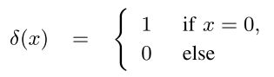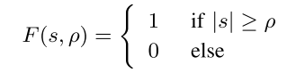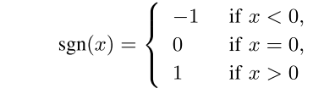[3–5]

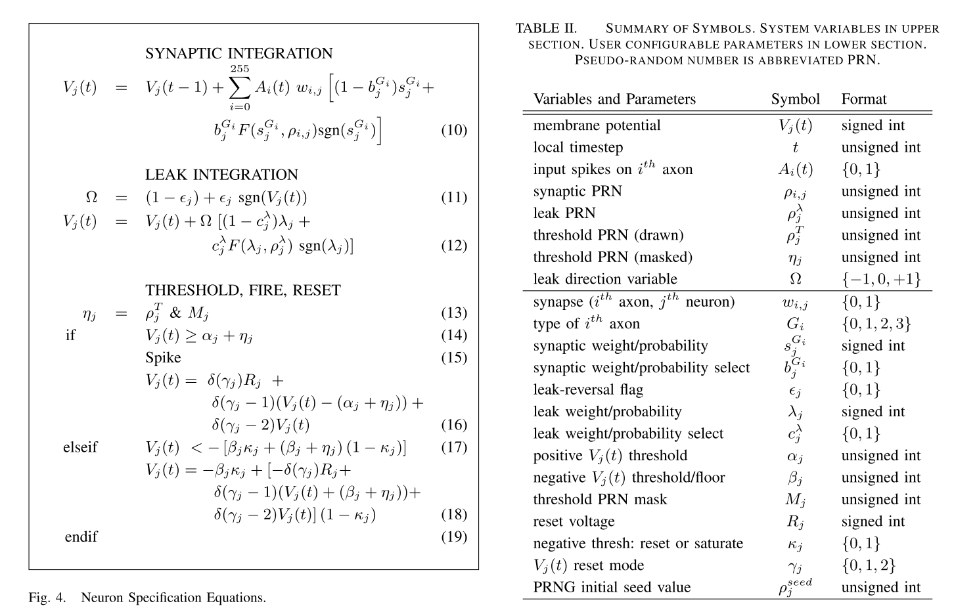[1–3]

## NeMo Event Flow

../../../../Volumes/Mark/Development/NeMo_Presentations/rvp/diagrams/time_../../../../Volumes/Mark/Development/NeMo_Presentations/rvp/diagrams/NeMoFlow

In blocks 1–18, we show the NeMo neuron model control flow for the forward event handler. The flow starts at the current simulation time, t, where t is measured in microseconds. If t > 1, there has been at least one neurosynaptic tick since the simulation has started. There are two event types that neurons receive: synapse messages and heart- beat messages. Synapse messages are set at a nanosecond resolution, with events occurring at t + 0.0001 + ε. Heart­–beat messages are sent at a larger time-slice, t + 0.1 + ε. In Figure 3, the synapse message processing is represented on the left column, and heartbeat messages are shown on the right. We use ε to represent a “jitter” factor, an extremely small random value used to ensure a deterministic ordering of events.

The synapse message process begins in Block 1, when the neuron receives a synapse message. The neuron first saves the current voltage value, Block 2, a double precision floating point value Vj, in the synapse message, Block 3. This is to facilitate reverse computation, by saving Vj in the message, when rolling back messages neurons are able to revert changes made during forward computation.

The neuron then performs the integration function, shown in Figure 3 as Block 4. This updates Vj with a new value. Neuron heartbeat messages are NeMo’s technique to synchronize neuron firing. In an LIF model, neurons integrate, leak, fire, and reset at specific intervals. To increase performance, a heartbeat message is sent only when a neuron activates. In Block 5, the neuron checks if it has already sent a heartbeat message. If it has not, it schedules a heartbeat message at t + 0.1 + ε, in Block 6. This action completes the neuron’s integration function for a particular axon. By executing this flow every time an axon message is received, NeMo recreates the integration formula in Figure 2, Equation (6).

When a heartbeat message is received, as shown in Block 7, the neuron begins its leak, fire and reset function. The neuron also saves its current membrane potential in the received message Blocks 8 and 9.

Blocks 10-11 calculate the time passed since the last time the neuron was live. Using this, the current leak value is calculated. Finally, in blocks 15-18, the neuron checks the threshold values and fires and/or resets.

## Further Information

|  |  |  |
| --- | --- | --- |
| A good summary of spiking neural networks:  http://goo.gl/4iIH7F | The TrueNorth neuron model paper:  http://goo.gl/XcZ99T |  |

## References

[1] Akopyan, F. et al. 2015. TrueNorth: Design and Tool Flow of a 65 mW 1 Million Neuron Programmable Neurosynaptic Chip. *IEEE Transactions on Computer-Aided Design of Integrated Circuits and Systems*. 34, 10 (Oct. 2015), 1537–1557.

[2] Amir, A. et al. 2013. Cognitive computing programming paradigm: A Corelet Language for composing networks of neurosynaptic cores. *Proceedings of the International Joint Conference on Neural Networks*. December (2013).

[3] Cassidy, A.S. et al. 2013. Cognitive computing building block: A versatile and efficient digital neuron model for neurosynaptic cores. *Proceedings of the International Joint Conference on Neural Networks*. (2013).

[4] Izhikevich, E.M. 2001. Resonate-and-fire neurons. *Neural Networks*. 14, 6–7 (2001), 883–894.

[5] Izhikevich, E.M. 2004. Which model to use for cortical spiking neurons? *IEEE Transactions on Neural Networks*. 15, 5 (Sep. 2004), 1063–1070.